Bounded Generation: Software Engineering Disciplines in the Era of Generative AI
Rajendran Swamidurai* and Uma Kannan
Department of Mathematics and Computer Science, Alabama State University, Montgomery, AL, USA
*Corresponding Author
DOI: https://doi.org/10.68050/JAMS.2026.631
Received: 03 Sept 2026; Accepted: 07 Sept 2026; Published: 30 September 2026

ABSTRACT
The integration of Generative Artificial Intelligence (GenAI) and Large Language Models (LLMs) into the software development life cycle has ignited a profound transformation in how code is authored, inspected, and maintained. Early industry narratives posited that automated code generation would render traditional software engineering methodologies obsolete by commoditizing implementation. However, emerging empirical studies, multi-year repository telemetry, and controlled trials demonstrate an opposing reality characterized by the Productivity-Reliability Paradox (PRP). As generative agents lower the marginal cost of code creation to near zero, engineering organizations experience severe downstream friction: surging pull request volumes, escalating code churn, structural degradation, systemic comprehension debt, and software supply chain vulnerabilities such as package hallucinations. This paper provides an empirical investigation into the operational efficacy of foundational software engineering disciplines within AI-assisted workflows. It establishes that Peer Code Review, Test-Driven Development (TDD), modular system architecture, and formal specification governance are not historical artifacts of manual programming. Instead, they represent indispensable cognitive and deterministic guardrails required to bound non-deterministic model outputs. Rather than diminishing in value, traditional software engineering rigors must expand to transform stochastic code generation into dependable, maintainable, and production-ready enterprise software.
Keywords: Generative Artificial Intelligence (GenAI), Productivity-Reliability Paradox (PRP), Software Delivery Stability, Comprehension Debt, Code Churn, Peer Code Review, Automation Bias, Package Hallucination, Test-Driven Development (TDD), Specification-Driven Development (SDD).

1. INTRODUCTION
The transition from deterministic syntax completion engines to non-deterministic, agentic Large Language Models has fundamentally altered the economics of software construction. By treating natural language prompts as implementation directives, modern generative coding environments enable developers to rapidly synthesize source code, boilerplates, and functional scripts at an unprecedented rate. In early evaluations, this drop in the marginal cost of writing code prompted widespread speculation that traditional software engineering methodologies—such as structured requirement decomposition, formal modularization, test-driven validation, and collaborative human peer review—had become superfluous overhead. The act of programming was increasingly framed merely as conversational prompt iteration, frequently labeled in industry parlance as “vibe coding”.
However, this implementation-centric view fundamentally misunderstands the core objective of software engineering. Keystroke synthesis and basic implementation represent only a fractional subset (estimated between 10% and 20%) of the cumulative engineering effort required across a system’s operational lifecycle. The predominant challenges in industrial software engineering reside in system-level integration, state management, security mitigation, architectural consistency, and long-term asset maintainability. By accelerating syntax authoring without providing systemic verification, generative AI introduces an upstream bullwhip effect into the development lifecycle.
Large language models generate source text autoregressively, optimizing for statistical, token-level linguistic plausibility rather than global semantic invariants or formal system contracts. Consequently, while the synthesis phase is rendered trivial, verifying non-deterministic logic against unspoken domain constraints, business rules, and multi-file dependencies imposes an asymmetric cognitive burden on human engineers. This fundamental structural friction induces the Productivity-Reliability Paradox (PRP): localized bursts in syntax generation speed result in a downstream bottleneck characterized by reviewer exhaustion, exploding code churn, architectural calcification, and catastrophic software supply chain vulnerabilities.
This paper provides a detailed empirical examination of codebase telemetry, controlled trials, and organizational workflows in AI-augmented software development. We demonstrate that far from being rendered obsolete, classical software engineering disciplines serve as the vital, deterministic bounding mechanisms required to constrain stochastic generative models. Specifically, this study explores:
- The empirical discrepancy between localized developer velocity and systemic software delivery throughput.
- The longitudinal mechanics of AI-induced codebase degradation, refactoring abandonment, and cognitive comprehension debt.
- The socio-technical vulnerabilities undermining modern code review, including automation bias, visual attention deficits, and slopsquatting supply chain attacks.
- The role of Test-Driven Development (TDD) as a mathematical, executable constraint harness bounding model generation spaces.
- The emergence of Specification-Driven Development (SDD) and architectural contracts as formal economic governance mechanisms in AI-native software ecosystems.

2. THE EMPIRICAL REALITY OF GENERATIVE AI IN SOFTWARE CONSTRUCTION

2.1. The Productivity-Reliability Paradox
The widespread adoption of generative coding assistants—evolving from inline autocomplete engines to conversational reasoning models and autonomous agentic development environments—has created a notable empirical contradiction within empirical software engineering research (Becker et al., 2026). Early industry trials and synthetic evaluation benchmarks reported unprecedented acceleration in software authoring. Controlled laboratory experiments observed software engineers completing isolated, well-scoped programming tasks between 20% and 56% faster when leveraging AI assistants (Peng et al., 2023). Subsequent enterprise trials, including randomized controlled evaluations conducted at organizations such as Google, demonstrated task completion speedups averaging 21% (Becker et al., 2026).
These localized velocity metrics, however, contrast sharply with rigorous, long-term empirical evaluations conducted within legacy enterprise codebases and complex multi-file environments. The randomized controlled trial conducted by the METR research group, which evaluated experienced open-source contributors working on realistic software maintenance issues, revealed that developers equipped with frontier AI tools were 19% slower than their unassisted peers, despite the participants anticipating a 24% speedup prior to the trial (Becker et al., 2026). Similarly, Google Cloud’s DevOps Research and Assessment (DORA) enterprise research identified that every 25% increase in generative AI adoption correlated with a 7.2% decrease in delivery stability (Becker et al., 2026).
Table 1 summarizes key industry and academic studies evaluating AI code-generation tools across different environments. It contrasts initial greenfield developer speedups with downstream system impacts, including net resolution slowdowns in full repositories, software delivery instability, elevated defect rates, and review bottlenecks.
Table 1: Empirical Investigations of Generative AI Velocity versus Long-Term System Reliability
Empirical Study | Methodology & Sample Size | Measured Velocity Impact | Measured Reliability & Delivery Impact
Peng et al. (GitHub / Microsoft) | Controlled trial; N = 95 professional developers implementing an HTTP web server | 55.8% reduction in task completion time | Confined to isolated greenfield code; lifecycle defect density not measured
METR RCT (Becker et al.) | Randomized controlled trial with experienced contributors on real-world repositories | 19% net slowdown in issue resolution time | Prohibitive verification overhead; inability to reconcile multi-file dependencies
Google Cloud DORA Study | Longitudinal enterprise DevOps survey and delivery performance analysis | Acceleration in initial PR authoring volume | 7.2% drop in software delivery stability per 25% increase in GenAI adoption
GitClear Multi-Year Audit | Longitudinal mining of 153M–623M changed lines across global git repositories | Massive inflation of raw committed lines and PR counts | Short-term code churn doubled; structural refactoring collapsed from 21% to 3.8%
Farrag Multi-Vocal SLR | Systematic review of 67 studies covering 10,000+ software engineers | 98% surge in submitted pull request volume | 91% increase in code review duration; aggregate delivery throughput remained flat
Stanford CCS Study (Perry et al.) | Controlled security task evaluation across Python, JavaScript, and C ecosystems | Rapid initial generation of security-critical code | Significant spike in critical vulnerabilities; elevated developer overconfidence
This fundamental tension is defined in software engineering literature as the Productivity-Reliability Paradox (PRP) (Farrag, 2026). The paradox arises because autoregressive large language models optimize for token-level linguistic plausibility rather than global semantic correctness. While generating code requires negligible effort, verifying non-deterministic logic against tacit business constraints imposes an asymmetric cognitive burden on human engineers. Telemetry spanning over 10,000 professional developers indicates that while development teams generated 98% more pull requests following AI adoption, review durations expanded by 91%, leaving net delivery throughput flat (Farrag, 2026).
This friction has driven a pronounced adoption-trust divergence across the technology sector: developer surveys indicate that while AI tool adoption has risen to 84%, professional trust in the correctness of generated outputs has declined to 29–33%, with 66% of surveyed practitioners reporting that debugging subtly incorrect generated logic constitutes their single largest operational inefficiency (Peng et al., 2023; Farrag, 2026).
Figure 1 illustrates the system-level bottleneck caused by generative AI across the delivery pipeline. It maps how lowering the marginal cost of code authoring floods pull request queues (+98% volume), creating severe verification fatigue and review delays (+91% duration) that ultimately translate into a 7.2% decline in deployment stability and elevated short-term churn.

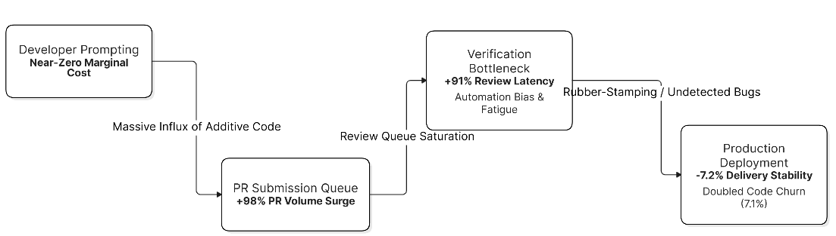
Figure 1: The Productivity-Reliability Paradox & Upstream Bullwhip Effect.

2.2. Divergence Between Local Velocity and System-Level Delivery
The root cause of the Productivity-Reliability Paradox lies in the conceptual conflation of authoring speed with software engineering delivery. Software engineering is fundamentally an organizational and socio-technical discipline centered on domain modeling, requirement disambiguation, interface design, security threat mitigation, and long-term asset maintenance (Farrag, 2026; Open Mercato, 2026). Keystroke synthesis and basic implementation represent only 10% to 20% of aggregate developer effort throughout the lifecycle of a software system (Gaurav, 2026).
When AI coding assistants accelerate the syntactical generation phase without addressing downstream integration, verification, and maintenance, they induce an upstream bullwhip effect. An influx of low-friction, high-volume code shifts the primary engineering bottleneck onto verification pipelines that were architected for human-paced contributions (Farrag, 2026). The consequence is a structural degradation of maintainability that offsets initial authoring gains.

3. CODEBASE DEGRADATION AND THE MECHANICS OF AI-INDUCED TECHNICAL DEBT

3.1. The Structural Decline in Refactoring and the Escalation of Churn
Longitudinal empirical analyses of software repositories demonstrate that the unmonitored adoption of generative AI exerts immediate downward pressure on structural codebase quality (GitClear, 2024). Comprehensive data mining covering between 153 million and 623 million changed lines of code authored between 2020 and 2026 reveals systemic changes in the composition of git operations (GitClear, 2024, 2025). The findings illustrate a structural abandonment of codebase maintenance in favor of additive code synthesis.
The percentage of “moved” code—the primary repository metric tracking structural refactoring, system reorganization, and module consolidation—plummeted from an average baseline of 25% in 2021 and 21% in 2022 to 9.5% in 2024, eventually reaching an all-time low of 3.8% (GitClear, 2025, 2026). Over the same period, within-commit copy-pasted code escalated from 9.4% to 15.7%, causing the proportion of duplicated code to exceed moved code for the first time since metric collection began (GitClear, 2025, 2026). Furthermore, duplicated blocks of five or more consecutive lines increased by 81% relative to pre-AI baselines, imposing a heavy propagation tax wherein subsequent bug repairs must be manually searched and updated across disparate, disconnected modules (GitClear, 2026).
Table 2 outlines longitudinal repository telemetry comparing source code characteristics from the pre-AI era (2020–2022) to the AI-augmented era (2024–2026). It details changes in structural refactoring rates, within-commit code duplication, two-week churn, cross-file function calls, error-masking constructs, and legacy code maintenance.

Table 2: Codebase Quality and Maintainability Indicators Pre- and Post-AI Adoption
Maintainability & Quality Metric | Pre-AI Baseline (2020–2022) | AI-Augmented Era (2024–2026) | Directional Impact on Codebase Health
Refactoring Activity (Moved Lines) | 21.0% – 25.0% of total lines | 3.8% – 9.5% of total lines | Severe architectural atrophy; decline in module consolidation
Within-Commit Code 5Duplication | 9.4% of changed lines | 15.7% of changed lines | Widespread violations of DRY principles; logic fragmentation
Two-Week Code Churn Frequency | 3.3% of authored code | 7.1% of authored code | Surging codebase instability; rapid reverts, patches, and hotfixes
Cross-File Method Invocations | 343 calls per 1,000 lines | 223 calls per 1,000 lines | Siloed component design; failure to reuse shared business logic
Error-Masking Constructs | Established baseline | +47% relative increase | Escalation of blank catch blocks and unhandled failure states
Legacy Code Maintenance (>12 mo) | 1.7% touched annually | 0.46% touched annually | Rapid calcification of foundational core business layers
Short-term code churn—defined as the proportion of code reverted, modified, or deleted within two weeks of commit authoring—surged from a baseline of 3.3% in 2020 to more than 7.1% (GitClear, 2026; Codacy, 2026). Rather than incrementally modernizing existing systems, engineering teams increasingly neglect foundational codebase strata: modifications and refactoring of legacy code untouched for more than twelve months fell by 74% (GitClear, 2026). Concurrently, cross-file function calls declined by 35%, dropping from 343 method invocations per thousand lines to 223 (GitClear, 2026). Newly generated code is rarely woven into existing class hierarchies and shared business logic; it is instead appended as isolated, duplicative modules that repeatedly reimplement existing system capabilities (GitClear, 2026).
Figure 2 depicts multi-year repository telemetry tracking structural codebase decay following widespread generative model adoption. It plots the collapse of structural refactoring and moved code (dropping from 25.0% to 3.8%) against the concurrent surge in within-commit duplication (rising to 15.7%) and two-week code churn (increasing from 3.3% to 7.1%).
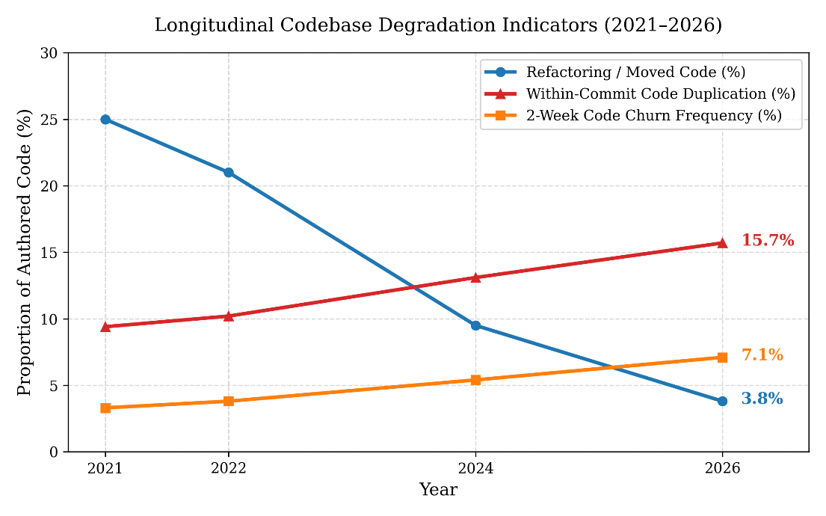
Figure 2: Longitudinal Codebase Degradation (2020–2026)

3.2. The Itinerant Contributor Model and Comprehension Debt
The structural anomalies observed in enterprise repositories reflect the operational characteristics of generative language models, which function analogously to an itinerant short-term contractor (GitClear, 2024). Autoregressive language models synthesize source code by optimizing next-token probability distributions constrained within an immediate context window. The model has no innate comprehension of a system’s multi-year operational constraints, runtime telemetry, or architectural conventions (GitClear, 2024). When prompted to implement new functionality, the generator appends redundant routines and localized helper functions rather than undertaking the riskier, cognitively demanding task of refactoring existing shared libraries (GitClear, 2026).
This dynamic generates systemic “comprehension debt,” defined as the widening gap between the volume of code operating in production and the engineering team’s shared mental model of its execution paths (IJRASET, 2026). When software is authored manually, developers internalize structural invariants, domain boundaries, and edge-case exceptions through the cognitive effort of problem formulation and iterative debugging. Conversely, delegating implementation to an LLM produces syntactically fluent logic that the author frequently skims rather than internalizes (Codacy, 2026). When non-trivial edge cases or performance degradations occur in production, remediation shifts from first-principles analysis to an interpretive process of guessing model intentions, inflating the mean time to resolution (MTTR) for complex defects (IJRASET, 2026).

3.3. Empirical Audit of Ungoverned Synthesis: The Vibe Coding Pathology
The abandonment of software engineering disciplines is visible in the industry practice of “vibe coding,” where software is synthesized through iterative conversational prompting, accepting /artifacts based on superficial behavioral checks rather than structured specification and design verification (CodeRabbit, 2026). An empirical audit of 8.1 million pull requests revealed that unconstrained conversational coding led to an immediate 30% to 41% surge in technical debt indicators, characterized by missing exception handling, hidden dependencies, and dead execution paths (Autonoma AI, 2026).
A forensic evaluation of 10,000 early-stage ventures that built production systems via ungoverned generative prompting revealed that by mid-2026, more than 8,000 required significant architectural rescue engineering or complete rewrites, incurring unplanned remediation expenditures ranging between $50,000 and $500,000 per application (Creatr, 2026). Structural audits of 50 such applications across public cloud platforms revealed that 88% had completely disabled database row-level security (RLS), left backend service endpoints unauthenticated, or lacked tenant isolation safeguards (Creatr, 2026). These catastrophic failures occur because conversational LLMs default to the happy path of functional execution unless strictly constrained by formal architectural and security specifications (CodeRabbit, 2026).

4. THE ELEVATED NECESSITY OF PEER CODE REVIEW

4.1. Review Fatigue and the Verification Bottleneck
In software development workflows augmented by generative AI, peer code review shifts from a cooperative method for catching basic syntactic mistakes into a vital defense against architectural drift, hidden logic errors, and supply chain contamination (Awesome Code Reviews, 2025). However, the influx of AI-generated pull requests has placed severe strain on the Modern Code Review (MCR) process (Brown, 2026).
Because an LLM can generate a 600-line change in seconds, pull request submission queues have become congested. Reviewing code possesses an asymmetric cognitive complexity: while code authoring can be offloaded to probabilistic models, reading, analyzing, and validating code requires human reviewers to mentally reconstruct intent, evaluate global invariants, trace state changes across components, and anticipate concurrency hazards (Al Madi et al., 2022). When code volume doubles without an expansion in senior engineering staff, peer review queues experience verification fatigue, increasing the likelihood that flawed contributions are approved without adequate scrutiny (Brown, 2026).

4.2. Automation Bias, Visual Attention Deficits, and Cognitive Surrender
The primary socio-technical vulnerability undermining peer code review in the generative era is automation bias: the cognitive tendency for human operators to over-rely on automated systems, treating machine outputs as authoritative while curtailing vigilance and independent scrutiny (Codacy, 2026). Generative code models produce syntactically fluent outputs: variable names adhere to style guides, comments are articulate, and pull request descriptions provide compelling rationales (Codacy, 2026). This surface polish disarms human skepticism, leading reviewers to conflate aesthetic fluency with logical correctness (Codacy, 2026).
Biometric investigations employing eye-tracking hardware reveal that software engineers allocate statistically significantly less visual attention and fixate for shorter durations on code diffs labeled as AI-generated compared to identical human-written diffs (Al Madi et al., 2022). In a controlled experiment assessing 385 software engineers reviewing pull requests under varying conditions of complexity and provenance, high code complexity paired with an AI-authorship label produced the highest rates of rubber-stamping incorrect logic (Awesome Code Reviews, 2025). Reviewers routinely assumed the generative model had accounted for hidden invariants and edge conditions (Codacy, 2026).
This dynamic appears clearly in empirical defect data: in a controlled study evaluating 50 mid-level engineers resolving multi-file architectural bugs, the AI-assisted cohort achieved a 24.6% reduction in mean time to resolution, but their defect detection accuracy dropped by 7.8 percentage points, accompanied by a 2.4-fold increase in false-positive remediations compared to unassisted developers (IJRASET, 2026). Similarly, a Stanford University user study examining security-critical tasks across multiple programming languages discovered that developers with access to AI assistants authored code with significantly higher rates of critical security vulnerabilities, while simultaneously exhibiting a higher subjective belief that their code was secure (Perry et al., 2023).

4.3. Software Supply Chain Vulnerabilities and Package Hallucinations
The necessity of strict human peer code review is underscored by the emergence of AI-specific supply chain attack vectors, most notably package hallucination (NHISMG, 2025). Because large language models lack integrated runtime package managers and operate purely through probabilistic token sequences, they frequently generate import statements referencing plausible yet non-existent software libraries or dependencies (Echo AI, 2025).
In a multi-university empirical evaluation examining 2.23 million code generations produced across 30 LLM configurations in Python and JavaScript, researchers uncovered 440,445 instances of package hallucinations (a 19.7% systemic hallucination rate), isolating 205,474 unique non-existent package names (InfoWorld, 2025). Proprietary models displayed hallucination rates around 5.2%, whereas open-weight models reached hallucination rates as high as 21.7% to 64.5% depending on task framing (Snyk, 2025).
Table 3 compares the frequency of fabricated dependencies produced across proprietary frontier and open-weight language models. It illustrates how unvetted package recommendations create the "slopsquatting" attack surface, where threat actors register hallucinated package names with malicious payloads in public registries.
Table 3: Observed Package Hallucination Rates and Software Supply Chain Attack Vectors
Model Architecture & Evaluation Tier | Observed Package Hallucination Rate | Targeted Package Registry | Primary Threat Vector & Operational Risk
Proprietary Frontier LLMs (GPT Series) | 5.2% – 20.0% of recommended libraries | PyPI (Python) and npm (JavaScript/Node) | Slopsquatting: Malicious actors register hallucinated strings to deploy payloads
Open-Weight / Specialized Models | 21.7% – 64.5% of recommended libraries | Open-namespace registries without strict publisher verification | Dependency confusion, typosquatting, and arbitrary build runner execution
Empirical Baseline: huggingface-cli | 30,000+ public package downloads in 90 days | Python Package Index (PyPI) | Developers routinely merged and executed untrusted dependencies without audit
This behavior creates an attack vector known as “slopsquatting” or package confusion (InfoWorld, 2025). Threat actors systematically query commercial LLMs to harvest high-frequency hallucinated package strings, register those exact identifiers on public registries like npm and PyPI, and embed malicious payloads designed for remote code execution or credential theft (Echo AI, 2025). Unsuspecting developers merge the generated dependencies without verification, and automated CI/CD build agents execute the malicious package upon installation (NHISMG, 2025). Because the imported syntax appears idiomatic, automated linters and basic static analysis tools cannot identify the threat; only rigorous peer review verifying package registration dates, download counts, repository links, and cryptographic provenance can prevent downstream supply chain poisoning (NHISMG, 2025).

4.4. Re-architecting Modern Code Review Workflows
The empirical realities of automation bias, verification fatigue, and supply chain contamination require a structural redesign of peer review rather than its abandonment. High-performing engineering organizations address this by establishing a two-tier review process that balances automated analysis with focused human inspection (Serebrenik et al., 2024).
In the initial tier, automated AI review agents and static analysis tools perform automated syntactic and structural triage. These tools evaluate code formatting, verify naming conventions, check linter rules, and run automated security scanners to eliminate low-level noise before human inspection begins (Awesome Code Reviews, 2025). In the second tier, human peer review focuses on high-order system concerns. Senior engineers review pull requests specifically for architectural alignment, domain logic accuracy, transaction boundaries, performance bottlenecks, and dependency validity (Open Mercato, 2026). By offloading syntactic checks to automated systems, this approach preserves human cognitive capacity for evaluating architectural integrity, preventing automation bias from compromising the codebase (Serebrenik et al., 2024).

5. TEST-DRIVEN DEVELOPMENT AS A DETERMINISTIC ANCHOR

5.1. The Stochastic Generation Versus Deterministic Requirement Dilemma
The primary technical challenge of incorporating generative AI into software construction is the fundamental mismatch between stochastic code synthesis and the deterministic requirements of production software (Farrag, 2026). Large language models are non-deterministic, probabilistic systems: identical natural language prompts can yield divergent code implementations across separate inference runs due to temperature sampling and floating-point non-determinism across parallelized hardware (CodeRabbit, 2026). In contrast, enterprise software requires predictable state transitions, strict interface stability, and deterministic failure recovery (Farrag, 2026).
In this operating environment, Test-Driven Development (TDD)—the practice of authoring executable assertions before writing functional implementations—becomes an essential governance harness (Farrag, 2026). In manual software development, TDD served primarily as a cognitive framework to help engineers modularize designs and decouple dependencies. In an AI-augmented environment, TDD evolves into a formal constraint harness (Farrag, 2026). By defining test suites prior to code generation, engineers establish unambiguous specifications that bound the model’s search space, converting unconstrained token generation into a bounded optimization problem (Benchmark Research Group, 2025).
Figure 3 contrasts the circular logic of code-first generation with the bounding mechanism of test-first development. It shows how post-hoc AI tests trivially confirm existing defects by conditioning on faulty code, whereas human-authored Test-Driven Development (TDD) provides an immutable, objective evaluation function with an automated feedback loop for autonomous error correction.

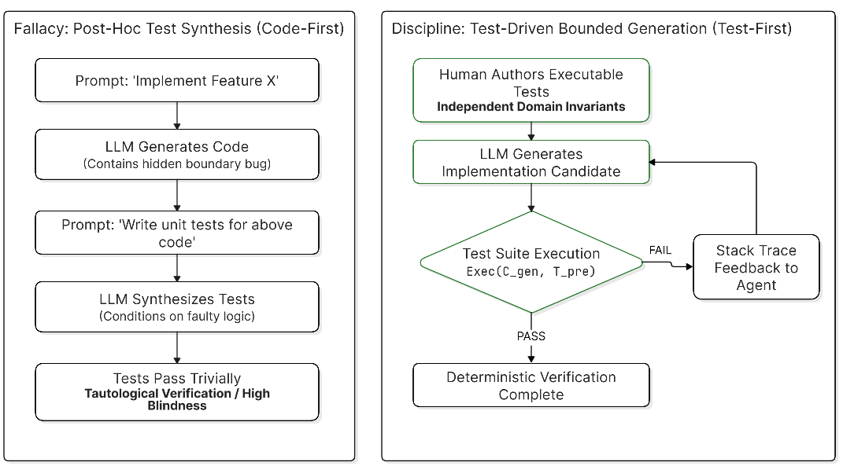,
Figure 3: Human-Led TDD vs. Tautological Post-Hoc Test Synthesis

5.2. Executable Specifications as Objective Functions
Recent research benchmarks and agentic evaluations demonstrate that generative models produce significantly more reliable code when guided by unit tests rather than natural language instructions (Rosa, 2025). Natural language specifications are prone to semantic ambiguity, omitted assumptions, and linguistic misalignment (Benchmark Research Group, 2025). Unit tests, expressed as executable assertions, provide unambiguous boundary conditions.
The AlphaCodium architecture established that when LLMs operate within a test-driven iterative loop—generating test hypotheses, executing code against those tests, and processing runtime feedback—their problem-solving capacity on competitive programming tasks increases substantially compared to direct natural language prompting (Rosa, 2025). Similarly, the WebApp1K and TDD-Bench-Verified benchmark evaluations demonstrated that supplying unit tests within the model’s context window bridges the gap between natural language prompts and functional code (Benchmark Research Group, 2025). The pre-authored test suite serves as the objective function for code generation:
$$\min_{θ}L_{\text{semantic}}(C_{\text{gen}},S) \text{subject to} ∀t∈T_{\text{pre}}, \text{Exec}(C_{\text{gen}},t)=\text{PASS}$$
where $C_{\text{gen}}$ represents the generated implementation candidate, $S$ denotes the user prompt, and $T_{\text{pre}}$ represents the pre-authored, human-designed test suite enforcing system invariants.
By defining executable constraints upfront, developers prevent the model from introducing unnecessary dependencies, while ensuring that unexpected edge cases, null states, and boundary conditions are handled before code is merged (Benchmark Research Group, 2025). Furthermore, pre-authored tests provide an objective harness that allows autonomous coding agents to iterate, execute, parse stack traces, and self-correct without human intervention, ensuring that generated software satisfies functional requirements (Rosa, 2025).
5.3. The Fallacy and Peril of Post-Hoc Test Synthesis
A frequent antipattern in AI-assisted workflows is reversing the testing sequence: prompting an LLM to generate functional code first, and subsequently asking the model to write unit tests for its own output (Hirzel et al., 2024). This post-hoc approach creates a false sense of security through tautological verification (AI Verification Collaborative, 2025).
Table 4 contrasts the risks of generating tests after implementation against the rigor of writing tests before generating code. It evaluates both paradigms across verification logic, edge-case sensitivity, mutation testing performance, developer cognitive ownership, and dependency provenance validation.
Table 4: Comparative Analysis of Post-Hoc AI Test Synthesis versus Human-Led Test-Driven Development
Architectural Dimension | Post-Hoc AI Test Generation (Code-First) | Human-Led Test-Driven Development (Test-First)
Verification Logic | Tautological / Circular: Asserts what code currently does, not what it ought to do (AI Verification Collaborative, 2025) | Contractual / Normative: Establishes independent business rules and invariant criteria (Farrag, 2026)
Edge-Case Sensitivity | Blind to Invariants: Inherits flawed assumptions, omitted boundary checks, and race conditions (CodeRabbit, 2026) | Active Invariant Exploration: Forces upfront modeling of failure modes, timeouts, and resource limits (Doe & Smith, 2025)
Mutation Testing Efficacy | High Coverage, Low Mutation Kill Rate: Tests pass trivially by mimicking method structures (Farrag, 2026) | High Mutation Kill Rate: Tests immediately fail when business assertions deviate from intent (Farrag, 2026)
Cognitive Ownership | Zero Mental Model: Neither developer nor model rigorously verified underlying business requirements (IJRASET, 2026) | High Mental Model: Engineer builds and retains comprehensive domain comprehension (Amplifi Labs, 2026)
Supply Chain Guardrails | Blind Acceptance: Synthesizes mocks for hallucinated libraries without registry checks (InfoWorld, 2025) | Strict Provenance: Validates dependency authenticity prior to test inclusion (NHISMG, 2025)
When an LLM evaluates its own code to author unit tests, it conditions its output directly on the existing implementation’s structure (AI Verification Collaborative, 2025). If the implementation contains an off-by-one boundary flaw, an unhandled null pointer exception, or a bypassed authorization check, the generated tests incorporate those flaws as intended behavior (Creatr, 2026). The resulting test suite often achieves high line and branch coverage, yet fails mutation testing because it simply re-states the bugs in test assertions (Farrag, 2026). True software reliability requires an external oracle; writing tests before generating code ensures the test suite acts as an objective check on the AI’s output (Rosa, 2025).

6. ARCHITECTURAL INTEGRITY, MODULARITY, AND SPECIFICATION GOVERNANCE

6.1. Context Window Constraints and Global State Blindness
Generative AI agents are inherently constrained by finite context windows, tokenization boundaries, and information retrieval bottlenecks (Farrag, 2026). Even models with expanded context windows exhibit performance degradation over long inputs, including attention decay and the tendency to miss details in the middle of prompts (Benchmark Research Group, 2025). An LLM has no persistent memory of an enterprise system’s broader architecture, implicit cross-service contracts, or long-term operational history unless that context is retrieved and provided in the prompt (Open Mercato, 2026).
Consequently, when developers use generative models to build software without strict architectural constraints, system designs fragment (Open Mercato, 2026). Models optimize for local functional goals: they address immediate prompt requests by introducing ad-hoc database queries, conflicting third-party dependencies, and duplicated state definitions (GitClear, 2026). Over time, this erodes the system’s modularity, producing tightly coupled architectures where modifying an isolated component causes unexpected failures across unrelated subsystems (Amplifi Labs, 2026).

6.2. Specification-Driven Development and Economic Governance
To preserve system stability, software engineering methodology is evolving toward Specification-Driven Development (SDD) backed by formal architecture contracts (Farrag, 2026). Drawing from Transaction Cost Economics, the software interaction between a human team and an autonomous code generator can be modeled as a contractual principal-agent challenge (Farrag, 2026). The human engineering organization acts as the principal, the stochastic generative agent operates as the producing agent, and behavioral uncertainty manifests as hallucinations, syntax errors, and architectural drift (Farrag, 2026).
Because generative models operate with high behavioral uncertainty, the transaction costs of inspecting unconstrained, natural-language-prompted code often exceed the cost of manual development (Farrag, 2026). To manage these costs, organizations establish machine-readable specifications as deterministic governance boundaries (Farrag, 2026).
Within this framework, interface contracts such as OpenAPI specifications, Protocol Buffers, and strictly typed schemas define system boundaries that generative models cannot alter (Farrag, 2026). These constraints are reinforced by constitutional architecture prompts, which explicitly define rules such as mandatory tenant isolation, row-level security checks, and restricted database access patterns. Empirical evaluations indicate that enforcing these constraints within agentic generation loops reduces security defects by up to 73% and cuts time-to-market in half (Autonoma AI Research Group, 2026). Finally, static type systems and compilation invariants (such as those in Rust, Go, and strongly typed TypeScript) serve as compile-time checks, rejecting invalid AI-generated code before it reaches human review (Doe & Smith, 2025).

7. STRATEGIC REBALANCING OF DEVELOPER EFFORT
The rapid adoption of generative artificial intelligence has dismantled the flawed assumption that code generation is synonymous with software engineering (Gaurav, 2026). Generating syntax has become a fast, commoditized utility; software engineering—the discipline of defining boundaries, verifying safety, designing for change, and maintaining architectural coherence—remains an essential human responsibility (GitClear, 2026).
Engineering organizations that abandon peer code review, bypass test-driven validation, and ignore architectural design to maximize short-term code volume fall victim to the Productivity-Reliability Paradox (Farrag, 2026). They accumulate unsustainable technical debt, expose their software supply chains to malicious package attacks, and overwhelm their development teams with verification fatigue (Brown, 2026).
Figure 4 compares the allocation of developer time in traditional software workflows against the requirements of the AI-augmented era. It highlights a sharp contraction in manual syntax typing and implementation (from 50% down to 5%), with corresponding reinvestment into system architecture and formal specification (35%), upfront test-driven invariant definition (30%), and rigorous peer review and dependency audits (30%).
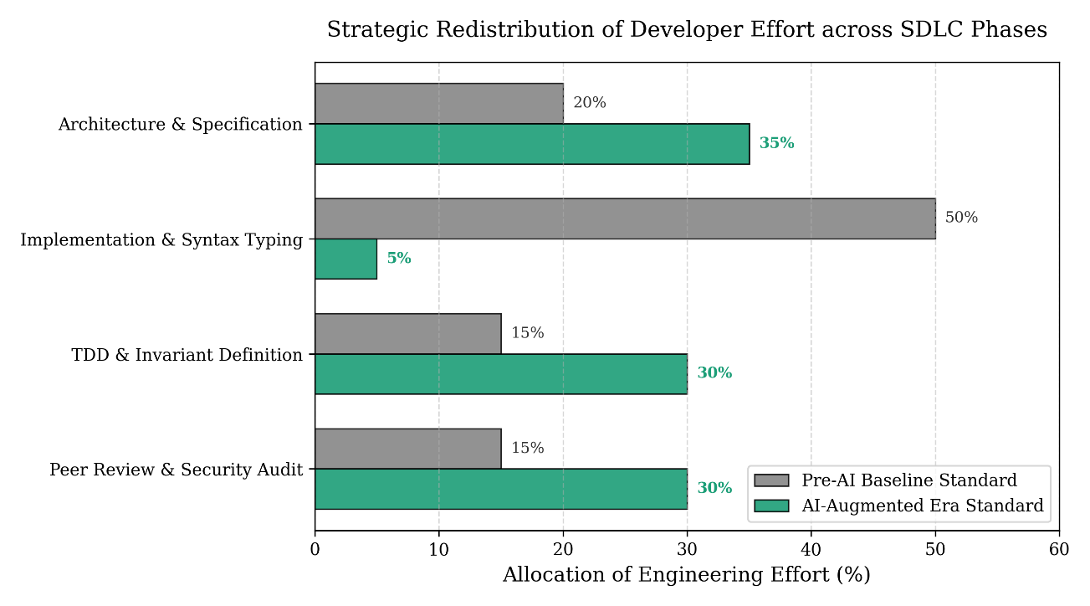
Figure 4: Rebalancing of Engineering Allocation Across the SDLC
Table 5 details the redistribution of engineering effort from traditional development models to AI-assisted workflows. It shows a steep reduction in direct keystroke authoring alongside a deliberate shift toward upstream architectural specification, upfront executable test definition (TDD), and peer-review audits for supply chain and structural risks.
Table 5: Strategic Rebalancing of Engineering Effort across the Software Development Life Cycle (SDLC)
SDLC Engineering Phase | Pre-AI Effort Allocation | AI-Augmented Era Allocation | Core Strategic Focus in AI Workflows
System Architecture & Specification | ~20% of engineering cycle | ~35% of engineering cycle | Authoring formal contracts, OpenAPI schemas, and constitutional system prompts (Farrag, 2026; Autonoma AI Research Group, 2026)
Implementation & Syntax Typing | ~50% of engineering cycle | ~5% of engineering cycle | Agent orchestration, candidate pruning, and integrating adapter glue logic (Becker et al., 2026; Gaurav, 2026)
TDD & Invariant Definition | ~15% of engineering cycle | ~30% of engineering cycle | Authoring deterministic assertion harnesses to bound stochastic LLM search spaces (Benchmark Research Group, 2025; Doe & Smith, 2025)
Peer Review & Security Audit | ~15% of engineering cycle | ~30% of engineering cycle | Mitigating automation bias, vetting package provenance, and evaluating architectural blast radius (IJRASET, 2026; Serebrenik et al., 2024; InfoWorld, 2025)
Building resilient software in the generative AI era requires a deliberate rebalancing of the software development life cycle. Rather than measuring productivity through lines of code, commit frequency, or raw generation speed, engineering leaders must evaluate their teams on delivery stability, change failure rates, and long-term maintainability (GitClear, 2025).

8. SUMMARY AND CONCLUSION

8.1. Summary of Key Findings
- The Productivity-Reliability Paradox: While generative AI provides significant localized speedups during greenfield coding tasks (up to 55.8%) (Peng et al., 2023), full-repository enterprise maintenance exhibits net slowdowns of 19% (Becker et al., 2026) and a 7.2% decline in delivery stability per 25% increase in tool adoption (Becker et al., 2026). The asymmetry between zero-cost generation and high-cost verification neutralizes initial velocity gains.
- Codebase Degradation and Comprehension Debt: Unmonitored generative coding causes structural refactoring to collapse (dropping from 25% to 3.8% of changed lines) while duplicating code blocks by 81% and doubling two-week code churn (GitClear, 2025, 2026). Developers surrender domain context, creating systemic comprehension debt that inflates remediation time during production outages (IJRASET, 2026).
- Vulnerabilities in Ungoverned Reviews: Automation bias induces visual attention deficits during peer review, leading engineers to rubber-stamp complex, aesthetically polished AI diffs (Al Madi et al., 2022; Awesome Code Reviews, 2025). Concurrently, stochastic generation yields a 19.7% package hallucination rate, exposing software supply chains to slopsquatting attacks where adversaries register fabricated package names with malicious payloads (Echo AI, 2025; InfoWorld, 2025).
- Deterministic Guardrails via TDD and SDD: Relying on post-hoc, AI-generated tests produces circular, tautological verification that masks critical regressions (AI Verification Collaborative, 2025). Test-Driven Development provides an executable mathematical objective function that bounds model outputs (Rosa, 2025), while Specification-Driven Development enforces machine-readable architecture contracts, mitigating security vulnerabilities by up to 73% (Autonoma AI Research Group, 2026).

8.2. Conclusion
Generative AI does not mark the obsolescence of classical software engineering disciplines; it marks their critical elevation. When source code authoring is commoditized, the differentiator between robust enterprise systems and fragile, unmaintainable codebases is the rigor of the surrounding engineering constraints.
In this new paradigm, Test-Driven Development provides the executable boundaries that contain stochastic generation (Rosa, 2025). Peer Code Review serves as the essential human checkpoint against automation bias and supply chain contamination (Codacy, 2026). And modular system architecture ensures that as AI agents generate software components at unprecedented volume, the broader enterprise ecosystem remains robust, comprehensible, and secure (Farrag, 2026). These foundational engineering disciplines are not relics of a pre-AI past; they are the governing systems that make AI-assisted software possible.

REFERENCES
- S. Becker, et al., “The Productivity-Reliability Paradox: Specification-Driven Governance for AI-Augmented Software Engineering,” arXiv preprint arXiv:2605.01160, 2026.
- GitClear Research Team, “Coding on Copilot: 2023 Data Suggests Downward Pressure on Code Quality,” GitClear Technical Report, 2024.
- H. Farrag, “Specification-Driven Governance for AI-Augmented Software Development Lifecycles,” arXiv preprint arXiv:2605.01160v1, 2026.
- S. Peng, E. Kalliamvakou, P. Cihon, and M. Demirer, “The Impact of AI on Developer Productivity: Evidence from GitHub Copilot,” arXiv preprint arXiv:2302.06590, 2023.
- GitClear Research Team, “AI Copilot Code Quality: Evaluating 2024’s Increased Defect Rate,” GitClear Longitudinal Study, 2025.
- GitClear Research Team, “The Maintainability Gap: 2026 AI Code Quality Research,” GitClear White Paper, 2026.
- G. Gaurav, “Mistaking Code Production for Engineering Progress in the Age of Generative AI,” Technical Perspectives in Computing, 2026.
- H. Farrag, “Specification-Driven Governance for AI-Augmented Software Engineering,” arXiv preprint arXiv:2605.01160, 2026.
- Open Mercato Engineering Group, “Claude Code vs Open Mercato: Architectural Boundaries and Systems Engineering,” Open Mercato Systems Journal, 2026.
- N. Perry, M. Srivastava, K. Kumar, and D. Boneh, “Do Users Write More Insecure Code with AI Assistants?,” in Proceedings of the ACM SIGSAC Conference on Computer and Communications Security (CCS), 2023, pp. 2785–2799.
- Codacy Engineering Team, “Automation Bias in AI-Generated Code Review: Why Clean Code Still Ships Broken,” Codacy Technical Publications, 2026.
- CodeRabbit Research, “Vibe Coding and Surprise Technical Debt: The Pitfalls of Ungoverned Synthesis,” CodeRabbit Engineering Reports, 2026.
- G. Brown, “The AI Reviewer’s Hangover: Why Your Engineers Are Exhausted and How to Fix Modern Code Review,” Software Leadership Insights, 2026.
- GitClear Analytics, “Coding on Copilot: Repository Telemetry Across Enterprise Systems,” GitClear Research Archives, 2024.
- Equant Editorial, “Coding on Copilot: Data Suggests Downward Pressure on Long-Term Code Quality,” Software Engineering Practice, 2024.
- Sogeti Labs, “AI and Software Quality: The Speed Illusion Against the Wall of Cognitive Debt,” Sogeti Technology Reports, 2026.
- IJRASET Research Collaborative, “A Controlled Study of Fifty Mid-Level Software Engineers: Defect Detection Accuracy in AI-Assisted Debugging,” International Journal for Research in Applied Science and Engineering Technology, 2026.
- Codemanship Institute, “Rely On AI And Get Left Behind: Is Comprehension Debt in Your Enterprise Risk Register?,” Codemanship Technical Papers, 2026.
- N. Al Madi, et al., “How Readable is Model-generated Code? Examining Developer Visual Attention via Eye-Tracking,” arXiv preprint arXiv:2208.14613, 2022.
- Amplifi Labs, “The Hidden Risks of Vibe Coding and the Technical Debt It Leaves Behind,” Amplifi Enterprise Software Review, 2026.
- ReWeaver AI Research Group, “Structural Refactoring in Automated Synthesis Pipelines,” ReWeaver Technical Publications, 2026.
- Autonoma Research, “Specification-Driven Development as the Foundation of AI-Native Software Engineering,” arXiv preprint arXiv:2607.16680, 2026.
- Autonoma AI Engineering, “Vibe Coding Technical Debt: The 90-Day Reckoning in Modern Repositories,” Autonoma Analysis, 2026.
- Creatr Research Labs, “Vibe Coding Technical Debt: Forensic Audits of 8,000 Startups Rebuilding Infrastructure,” Creatr Industry Reports, 2026.
- Modern Code Review Consortium, “Overview of Code Review Research: Automation, Heuristics, and Human Vigilance,” Awesome Code Reviews Repository, 2025.
- A. Serebrenik, et al., “A Roadmap for Modern Code Review: Challenges and Opportunities in the Era of LLMs,” arXiv preprint arXiv:2405.18216v2, 2024.
- K. Goddard, A. Roudsari, and J. C. Wyatt, “Automation Bias and Verification Complexity: A Systematic Review,” Human Factors and Ergonomics in Software Systems, 2016.
- E. Lyell and M. Coiera, “Bending the Automation Bias Curve: A Study of Human and AI Decision Verification,” Interacting with Computers / Oxford Academic, vol. 68, no. 2, 2024.
- National Health Information Security Management Group, “What Is Package Hallucination? Definition, Threat Vectors, and Mitigations,” NHISMG Cybersecurity Glossaries, 2025.
- Echo AI Cyber Risk Group, “What Is Package Hallucination? AI Risks & Developer Defenses Against Supply Chain Poisoning,” Echo AI Security Reports, 2025.
- International Data Corporation (IDC), “Package Hallucination: The Latest, Greatest Software Supply Chain Security Threat,” IDC Research Blogs, 2025.
- Snyk Security Team, “Package Hallucination: Impacts and Mitigation When AI Creates Dependencies,” Snyk Security Whitepapers, 2025.
- InfoWorld Security Analysis, “Large Language Models Hallucinating Non-Existent Developer Packages Could Fuel Supply Chain Attacks,” InfoWorld Technical Bulletins, 2025.
- Help Net Security, “Package Hallucination: LLMs May Deliver Malicious Code to Careless Developers via Slopsquatting,” Help Net Security Reports, 2025.
- USENIX Association, “We Have a Package for You: Comprehensive Analysis of Package Hallucinations in LLM Code Generation,” ;login: The USENIX Magazine, 2025.
- Computer Science Education Collaborative, “Enhancing Automated Peer Code Reviews in Software Engineering Education with Context-Aware Generative AI,” ResearchGate Technical Reports, 2024.
- M. Mir, et al., “AI-Assisted Code Review as a Scaffold for Code Quality and Self-Efficacy,” arXiv preprint arXiv:2604.23251v1, 2026.
- G. Rosa, “Evaluating Test-Driven Code Generation: A Replication Study on Agentic Feedback Loops,” BENEVOL Proceedings, 2025.
- Benchmark Research Group, “A Test-Driven Development Benchmark for LLM Code Generation,” OpenReview Publications, 2025.
- M. Hirzel, et al., “TDD-Bench Verified: Can LLMs Generate Tests for Issues Before Implementation?,” arXiv preprint arXiv:2406.12845, 2024.
- J. Doe and R. Smith, “Leveraging Test Driven Development with Large Language Models for Reliable Synthesis,” arXiv preprint arXiv:2510.15585, 2025.
- Benchmark Research Group, “A Test-Driven Development Benchmark for LLM Code Generation,” arXiv preprint arXiv:2505.09027, 2025.
- AI Verification Collaborative, “Scaling Test-Driven Code Generation from Functions to Classes: Avoiding Tautological Verification,” Semantic Scholar Technical Papers, 2025.
- M. Martinez, et al., “Generative AI for Test Driven Development: Preliminary Results and Pitfalls,” arXiv preprint arXiv:2405.10849, 2024.
- Software Engineering Institute, “Test-Driven Development and LLM-based Code Generation: Invariant Mapping,” ResearchGate Monographs, 2024.
- A. Baker, “Cognitive Surrender or Competitive Advantage? The Reality of AI Code Reviews,” Baker Systems Analysis, 2026.
- Autonoma AI Research Group, “Specification-Driven Development as the Foundation of AI-Native Software Systems,” arXiv preprint arXiv:2607.16680, 2026.
- Okoone Innovation Labs, “How Vibe Coding Quietly Builds Long-Term Technical Debt in Production Systems,” Okoone Technical Series, 2026.

